W2-S2 PRACTICE
OOP MANIPULATION

 Learning objectives
- Implement a class in Dart with specific attributes and methods
- Define and use default constructors.
- Implement named constructors and parameterized constructors.

- Implement Value Objects, immutable objects
- Manipulate enumerations
- Handle Exceptions

- Identify const and final attributes
- Be able to encapsulate data (private members, getters)
- Implement Operator Overloading
- Implement aggregation and composition of classes

 No AI tools allowed to solve this practice

How to submit?
- Push your final code on your GitHub repository
- Then attach the GitHub path to the MS Team assignment and turn it in

 Are you lost?
Read the following documentation to be ready for this practice:

- Classes
- Constructors
- Methods

EX 1 – Employee Class


In this exercise, you will be working on an existing Employee class. Read the start code!

We provide the start code of the Employee class and the main that creates a few instances of Employee.
We also provide the Skill enum with various values.
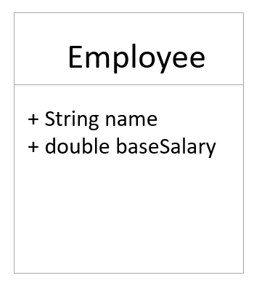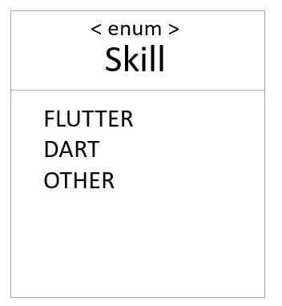
Q1- Add the following new attributes to the Employee class:
- skills: A list of skills
- address: An Address class that contains street, city, and zipCode attributes
- yearsOfExperience: An integer representing the employee's experience in years

Q2 - Update the constructor to initialize the new attributes.
Add named constructors for specific types of employees
Example: mobileDeveloper constructor that assigns FLUTTER and DART skills

Q3 - Make all attributes private and provide getter methods for accessing them.
Q4 – Add a method to compute the salary of the employee (you can create your own rules!):
Salary Specification:
Base salary: $40,000.
Each year of experience adds $2,000.
Each skill adds a different bonus:
- FLUTTER: $5,000.
- DART: $3,000.
- OTHER: $1,000.
Note: don’t forget to define attributes const or final whenever possible!

EX 2 – Bank System


In this exercise, you will be working on a Bank account and a Bank class. Read the start code!

Bank Account

Q1 - Decide which attributes make sense for a bank account
Q2 – Implement the following methods

balance():
- Returns the current balance

withdraw(double amount)
- Deducts the given amount from the account balance.
- If the balance goes below 0, it should throw an exception.

credit(double amount)
- Adds the given amount to the account balance.

Bank

Q3 - Decide which attributes make sense for a bank
- The Bank class manages a list of accounts and ensures the uniqueness of each account ID.

Q4 – Implement the following method

Account createAccount(int accountId, String accountOwner)
- Create a new bank account
- Ensure that the account ID is unique. Otherwise, throw an exception
- Add the account to the bank list and return it

Q5 – Draw a UML class diagram that reflects your implementation.
- Attributes and methods of the BankAccount class.
- The relationship between Bank and BankAccount (composition or aggregation)

This is composition. The bank creates its accounts in createAccount and keeps them in its own list, so the accounts don’t exist independently of the bank.
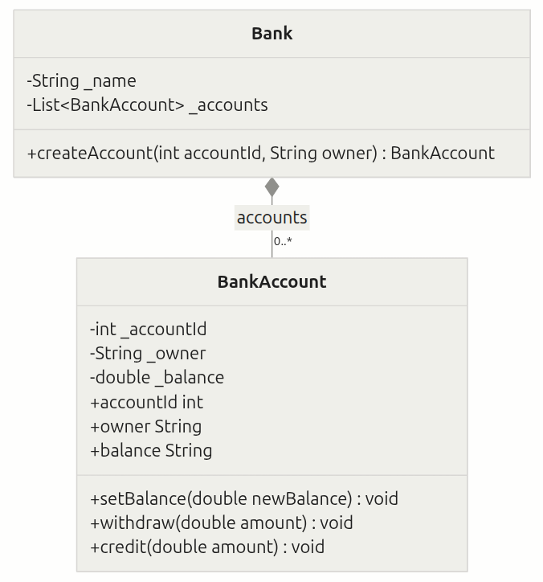

EX 3– Duration OPTIONAL


In this exercise, you need to create a CustomDuration class, similar to Dart's built-in Duration.
https://api.dart.dev/stable/3.5.3/dart-core/Duration-class.html

You need to understand:
- the concepts of immutability
- operator overloading
- custom methods

Q1 –Attribute and constructors
- Internally store the duration as a number of milliseconds (private field).
  - Duration shall always be greater or equal to 0

- Constructor:
  - fromHours(int hours): Constructs a duration from a number of hours
  - fromMinutes(int minutes): Constructs a duration from a number of minutes
  - fromSeconds(int seconds): Constructs a duration from a number of seconds

Q2- Overloaded Operators:
- >: Compare two durations, returning true if one duration is greater than the other.
- +: Add two durations, returning a new CustomDuration object.
- -: Minus two durations, returning a new CustomDuration object (if possible)

